
Cixi Tianhao Electric Technic Co.,ltd
NO1.Sijie Village GuanFu Road Fuhai Town, Cixi, ZheJiang, China
TEL: 0086-574-23861582 FAX: 0086-574-63688108 E-mail:trade@dispensing-th.com Http://www.dispensing-th.com

T&H Two component Mixer/Meter dispensing machine (automatic clearing)
TH-2004AB2
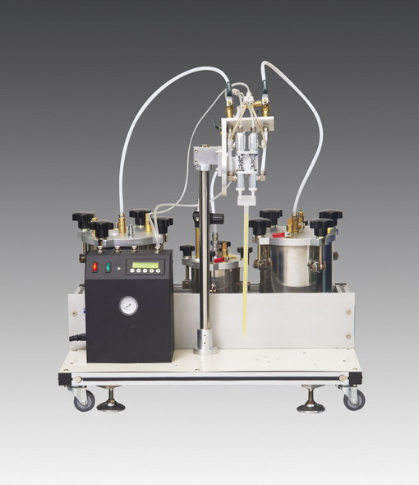
The TH-2004AB2 machine has automatic cleaning function and have wheel can rolling with the frame.
1.When the machine stop work, all have a little glue leave in the tube and valve, if no cleaning in time, the glue will cure in the valve and glue ,so touch the next time to using the machine, you no need to cleaning by hand, you only switch cleaning supplier systems. The cleaning liquid automatic into the valve and fitting, automatic finish cleaning. so that good your save more time to cleaning ,same good for the machine oneself maintenance.

2.The machine have wheel, so that well you to moving the machine. Very easy and simple

Features
1.TH-2004AB2.funaction is automatic mix/meter. Then handle dispensing,
2.Have a big capability cartridge, No need to transfer material, Avoids waste.
3.Adopted with the TH-700J pneumatic double-liquid valve can interrupt the flow quickly without dripping.
3. Static mixer is used which can mix liquid evenly. Mix evenly and quickly.
4.The auto-cycling function can reduce labor intensity and increase the production.
5.Digital circuit timing controlling technology was used, and the dispensing time can be set through the digital dial.
6. The pedal /ring/inductive switches can be chosen.
7. Complete with an accessory dispensing kit.

Specification
Standards: CE approved
Control: by air and electric
Mixing method: Automatic and static mixer
Tank: 1gallon (Other capacity can be chosen)
Valve: TH-700J
Operating Model: Manual, Timer/cycles Leak-proof function: valve with Vacuum device
Liquid ratio: 1:1-3:1 (can be adjusted)
Dispensing time: 0.001S-9.999S
Cycles (interval) time: 0.1S-9.9S
Repeatability: +/-0.01%
Frequency : > 300times/minute
Voltage: 110V/220V 50Hz
Internal Voltage: 24 VDC
Power: < 15W
Weight: 58 kgs
Air Input: 7KgF/cm2 Dry air without lubrication
Air Output: 0.1-7KgF/cm2
Size: 75X42X30cm

Complete with an accessory dispensing kit
NO. | Descriptions | QTY | Note
1 | TH2004AB Dispenser controller | 1pcs | IN Middle box
2 | 4kgs Tank | 3pcs | IN big box
3 | TH-700J Valve | 1pcs | IN small box
4 | Foot pedal | 1pcs | IN small box
5 | Tee | 3pcs | IN Middle box
6 | STATIC MIXER | 3pcs | IN Middle box
7 | Electric line(plug) | 1pcs | IN small box
8 | Air tube connect controller and valve | 1pcs | IN small box
9 | Air tube using for controller | 1pcs | In small box
10 | Glue tube for tank(short) | 3pcs | In tank
11 | air tube (white) | 3pcs | In tank
12 | Air pressure gauge | 1pcs | In tank
13 | Handle( black) | 9pcs | In tank
14 | Machine tool with adjusting ratio | 1pcs | In small box
15 | Dispensing tips | 10pcs | In middle box
16 | frame | 1pcs
17 | manual book | 1pcs | in middle box

